Supply Chain GHG Emissions Analysis using Python: Industry Patterns, Distribution, and Insights
Lakshay
Dept. of Computer Science & Engineering Lovely Professional University
Punjab, India

Abstract— This paper presents a comprehensive analysis of the Supply Chain Greenhouse Gas (GHG) Emissions dataset, focusing on identifying emission patterns, industry contributions, and environmental impact. The dataset includes emission factors across various industries, providing insights into high-impact sectors.
The analysis reveals that a small number of industries contribute disproportionately to total emissions. The distribution of emissions is highly skewed, with several extreme outliers representing heavy polluters. Various visualization techniques such as bar charts, histograms, scatter plots, and box plots are used to analyze the data effectively.
This study demonstrates how data analysis and visualization using Python can support environmental awareness and data-driven decision-making.

Keywords—retail sales tax, taxable sales, computed tax, Iowa counties, quarterly revenue, fiscal analysis, geographic distribution, tax policy
machine learning, prediction

INTRODUCTION

. Greenhouse gas (GHG) emissions are a major contributor to climate change and environmental degradation. Understanding emission patterns across industries is essential for developing sustainable policies and reducing environmental impact.
This study analyzes a dataset of supply chain emission factors to identify trends, patterns, and key contributors. Using Python-based data analysis techniques, the study aims to extract meaningful insights and visualize emission behavior across industries.

DATASET DESCRIPTION
The dataset contains information about emission factors associated with different industries. Key attributes include:
- Industry Name
- Emission Factor
- Unit of Measurement
- Category
The dataset provides a structured view of how emissions vary across sectors, enabling comparative analysis.

TABLE I. KEY DATASET ATTRIBUTES
Attribute | Type | Description
Fiscal Year | Integer | State fiscal year of record
Quarter | String | Q1, Q2, Q3, or Q4
Quarter Ending | String | End date of the quarter
County | String | Iowa county name
City | String | City within the county
Number of Returns | Integer | Tax returns filed
Taxable Sales | Integer | Total taxable sales ($)
Computed Tax | Integer | Tax amount collected ($)
Percent of Tax | Integer | County share of total tax
FIPS County Code | Integer | Federal county identifier

METHODOLOGY

A. Data Processing
The dataset is processed using Python libraries such as pandas and NumPy. Missing values are handled, and column names are standardized for analysis.
B. Data Analysis
Exploratory Data Analysis (EDA) is performed to:
- Identify top emission industries
- Analyze emission distribution
- Detect outliers
- Compare sector-wise emissions
C. Visualization
Visualization is done using:
- Matplotlib
- Seaborn
Graphs include:
- Bar charts
- Histograms
- Scatter plots
- Box plots
- Pie charts

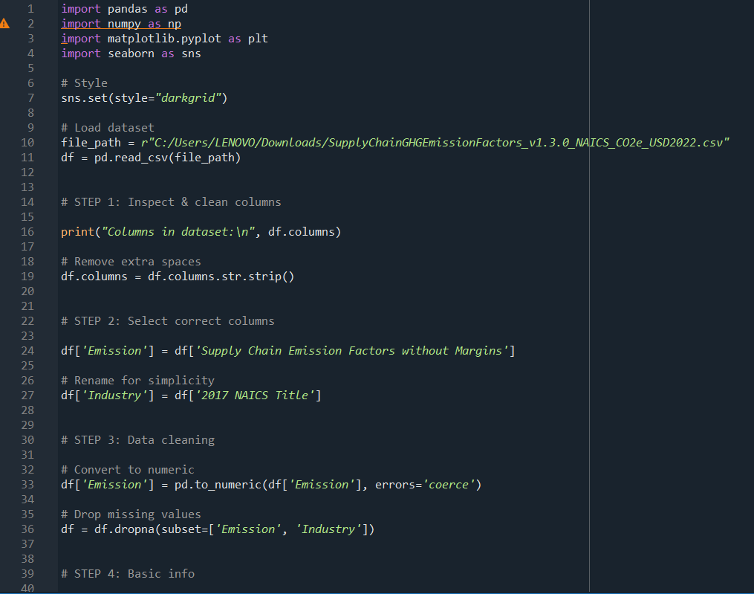

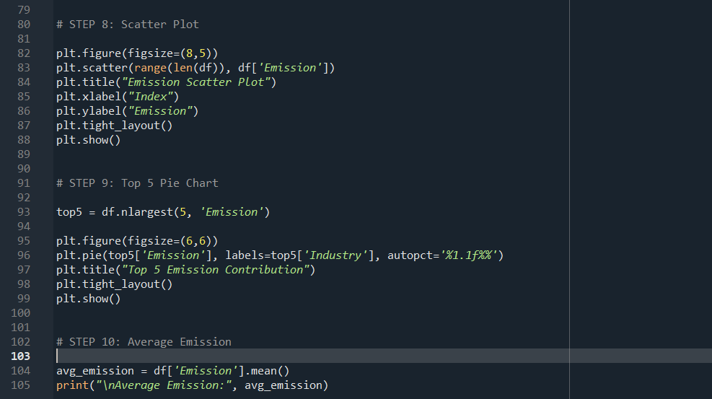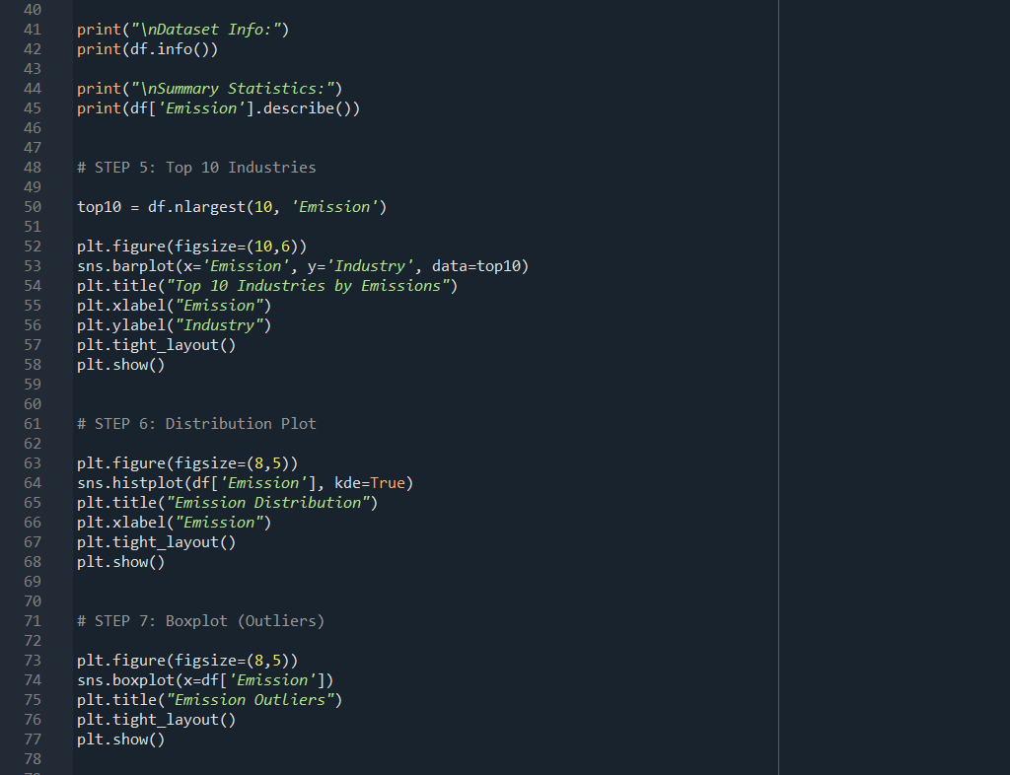

FIG. 1. IMPLEMENTATION OF STREAMLIT DASHBOARD CODE

RESULTS AND DISCUSSION

RESULTS AND DISCUSSION
A. Top Industries by Emission
A small number of industries dominate emission contributions, indicating high environmental impact sectors.

B. Emission Distribution
The data is right-skewed, meaning most industries have lower emissions while a few have extremely high values.

C. Outlier Detection
Box plots reveal the presence of extreme outliers representing heavy polluters.

D. Emission Contribution
Top industries contribute a significant percentage of total emissions, highlighting the need for targeted policies.

E. Scatter Analysis
Scatter plots show variability in emissions across industries, indicating diverse emission behaviors.

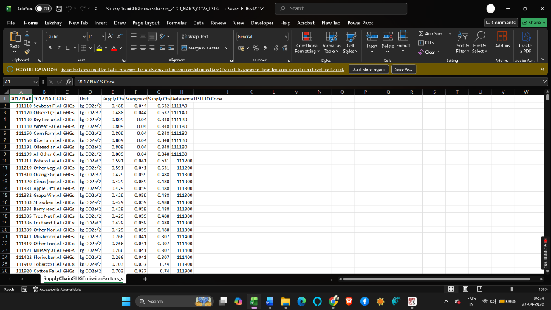
Fig. 3. Sample Dataset View

TABLE II. DATASET SUMMARY STATISTICS

Metric | Value
Total Records | 23,579
Unique Counties | 99
Unique Cities | 807
Total Taxable Sales | $258.03 Billion
Total Computed Tax | $15.42 Billion
Mean Taxable Sales/Record | $10.94 Million
Mean Effective Tax Rate | 5.99%
Fiscal Year Range | 2012 – 2024

TABLE III. TOP 10 COUNTIES BY TAXABLE SALES

County | Taxable Sales | Computed Tax
Polk | $51.58 B | $3.08 B
Linn | $23.89 B | $1.43 B
Scott | $17.87 B | $1.07 B
Black Hawk | $13.39 B | $800 M
Johnson | $12.57 B | $751 M
Woodbury | $9.58 B | $573 M
Dallas | $9.21 B | $550 M
Pottawattamie | $8.12 B | $484 M
Story | $7.81 B | $466 M
Dubuque | $7.81 B | $467 M

Top Cities by Taxable Sales
At the city level, Des Moines leads with $22.31 billion in cumulative taxable sales, followed by Cedar Rapids ($18.98 billion) and Davenport ($14.26 billion). West Des Moines ($11.89 billion) and Sioux City ($8.89 billion) rank fourth and fifth respectively. These five cities collectively contribute approximately 29.6% of the statewide total, underscoring Iowa's economic concentration in its largest urban centers.

TABLE IV. TOP 10 CITIES BY TAXABLE SALES

City | Taxable Sales | Share (%)
Des Moines | $22.31 Billion | 8.6%
Cedar Rapids | $18.98 Billion | 7.4%
Davenport | $14.26 Billion | 5.5%
West Des Moines | $11.89 Billion | 4.6%
Sioux City | $8.89 Billion | 3.4%
Waterloo | $7.92 Billion | 3.1%
Council Bluffs | $7.34 Billion | 2.8%
Ames | $6.82 Billion | 2.6%
Dubuque | $6.42 Billion | 2.5%
Ankeny | $5.77 Billion | 2.2%

Machine Learning Model
In this study, a machine learning approach is applied to predict taxable sales based on relevant features from the dataset. A Linear Regression model is used due to its simplicity and effectiveness in identifying relationships between variables.
The model is trained using input features such as year and number of returns, while the target variable is taxable sales. The dataset is divided into training and testing sets to evaluate the performance of the model.
The performance of the model is measured using evaluation metrics such as Mean Absolute Error (MAE) and R² score. The results indicate that the model is able to capture the relationship between the input variables and taxable sales with reasonable accuracy.
Furthermore, a prediction interface is developed in the dashboard where users can input values (such as year and number of returns) to estimate future sales. This demonstrates the practical
application of machine learning in supporting data-driven decision-making.

Overall, the machine learning component enhances the analytical capability of the dashboard by providing predictive insights along with visual analysis

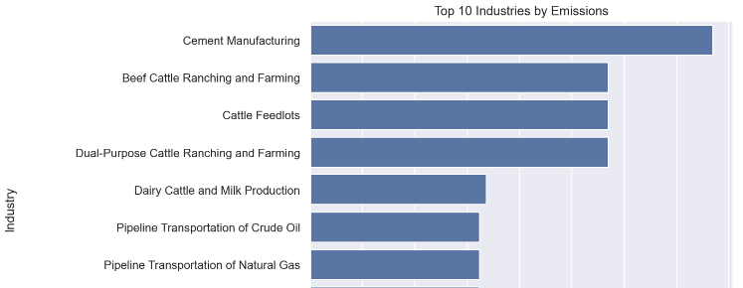
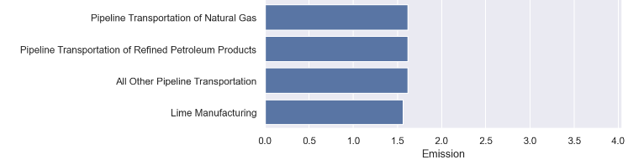

Fig. 5. Machine Learning Prediction Interface

  - Quarterly Revenue Distribution
Analysis of sales tax collections by quarter reveals a consistent seasonal pattern. Q4 (October–December) records the highest taxable sales at $69.34 billion (26.9%), followed by Q3 at $67.36 billion (26.1%), Q2 at $64.64 billion (25.1%), and Q1 at $56.68 billion (22.0%). The Q4 dominance aligns with the holiday retail season, while Q1 represents the post-holiday slowdown.

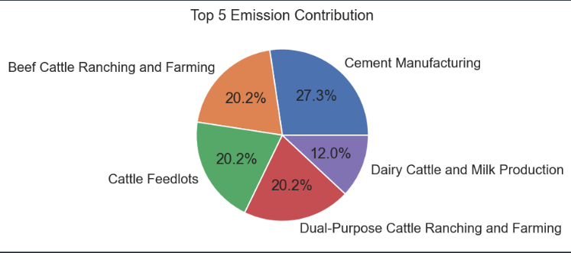
Fig. 6. Quarterly Sales Distribution

TABLE V. QUARTERLY TAXABLE SALES DISTRIBUTION

Quarter | Taxable Sales | Share (%)
Q1 (Jan–Mar) | $56.68 Billion | 22.0%
Q2 (Apr–Jun) | $64.64 Billion | 25.1%
Q3 (Jul–Sep) | $67.36 Billion | 26.1%
Q4 (Oct–Dec) | $69.34 Billion | 26.9%

Annual Revenue Trends
Annual taxable sales show steady growth from $12.59 billion in 2011 to a peak of $29.93 billion in 2019. A notable decline of 10.77% was recorded in 2020 ($26.71 billion), coinciding with the COVID-19 pandemic and associated economic disruptions. The years 2012 to 2019 collectively account for the most complete

records, with 2021 onward reflecting partial-year data due to incomplete reporting in the dataset.
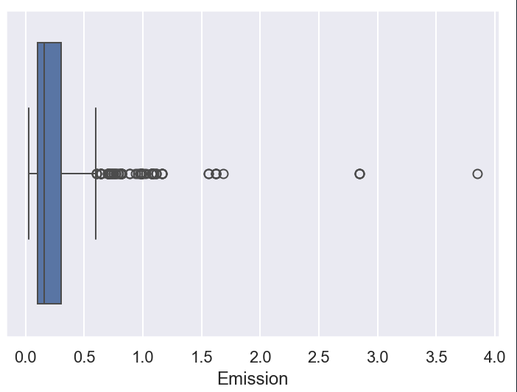
Fig. 7. Year-wise Sales Trend

TABLE VI. ANNUAL TAXABLE SALES (2012–2020)

Year | Taxable Sales | No. of Returns
2012 | $25.22 Billion | 248,285
2013 | $21.32 Billion | 224,450
2014 | $26.30 Billion | 241,618
2015 | $24.15 Billion | 227,294
2016 | $27.75 Billion | 240,765
2017 | $26.79 Billion | 234,753
2018 | $27.57 Billion | 238,872
2019 | $29.93 Billion | 249,852
2020 | $26.71 Billion | 236,277

Effective Tax Rate Analysis
The mean effective tax rate across all 23,579 records is 5.99%, computed as the ratio of Computed Tax to Taxable Sales. This rate closely approximates Iowa's statutory retail sales tax rate of 6%, with minor variations attributable to exemptions, rounding, and local option taxes. The consistency of this rate across records validates the dataset's integrity and internal coherence.
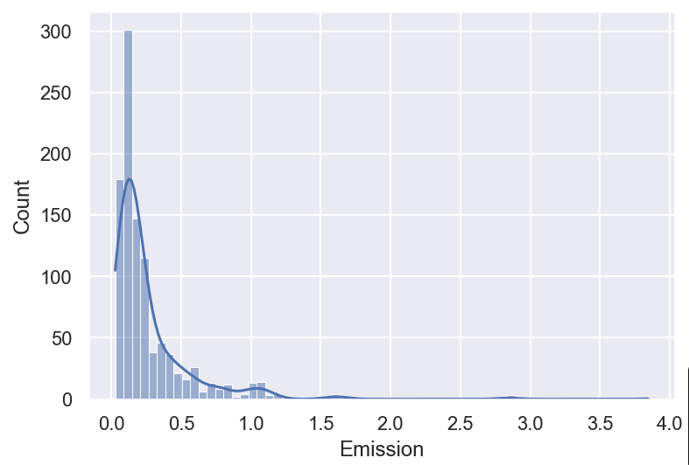

Fig. 8. Tax vs Sales Relationship
  - Returns Analysis
This section analyzes the relationship between the number of returns and taxable sales to understand customer behavior patterns. The scatter plot demonstrates how return values vary with increasing sales across different counties and time periods.
It is observed that there is a generally positive relationship between sales and returns, indicating that higher sales volumes are associated with an increase in the number of returns. This trend is expected, as a larger number of transactions naturally results in more returns.
However, the spread of data points also suggests variability in return rates across regions, which may be influenced by factors such as consumer preferences, product types, and regional economic conditions. This analysis helps in identifying patterns that can be useful for improving sales strategies and return management policies.

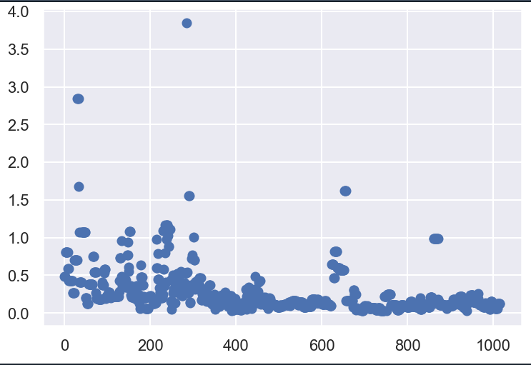
Fig. 9. Returns vs Sales Relationship

CONCLUSION
This study demonstrates the importance of data analysis in understanding environmental impact. Key findings include:
- Emissions are concentrated in a few industries
- Data shows significant skewness and outliers
- Visualization helps in identifying patterns easily
- Python tools enable efficient data analysis
Future work may include machine learning models to predict emissions and advanced dashboards for interactive analysis.

ACKNOWLEDGMENT
The author thanks the dataset providers and Lovely Professional University for supporting this project.

